Cloud Economics Analysis

Madelyn Wolf
Information Technology, Arizona State University
IFT 320: Managing the Cloud
Professor John Lewis
September 21st, 2025

Cloud Economics Analysis
The topic of cloud infrastructure versus traditional on-prem infrastructure is highly debated. Cloud infrastructure offers scalability, flexibility, reliability, and enhanced security. In comparison, traditional on-prem infrastructure is less scalable, less flexible, and less reliable, though they do offer a highly secure environment and often simplify compliance with regulatory bodies (Dell Technologies, 2025). When deciding between a traditional environment or a cloud one, it is important to account for costs, whether they are indirect or direct. Some examples of indirect costs are networking, storage, software, maintenance and upgrades, support, and training (Kale, 2015). These are harder to predict, especially in the case of traditional infrastructure as hardware degrades over time. With traditional infrastructure, it is also important to consider security. An on-premises data center/server farm will require additional security, which increases costs. This could include more security personnel, more cameras, additional RFID badges, etc. More technicians will also be required to monitor and maintain the data center, increasing operational costs. Operating system licensing will also need to be obtained.
The two server farms require different infrastructure. The following table compares the two regarding their cost in a traditional on-prem scenario.
Server Farm One (8 Servers) | Server Farm Two (12 Servers)
Servers (Includes CPU, RAM, and SSD): $30,325.49 x 8 = $242,603.92 | Servers (Includes CPUs, RAM, and SSD):  $37,964.36 x 12 = $455,572.32
Perpetual OS Licensing: $0 | Perpetual OS Licensing: $81,252
Est. 5-year Energy Cost: $56,239.20 | Est. 5-Year Energy Cost: $83,423.25
Total Cost of Server Farm: $298,843.12 | Total Cost of Server Farm: $620,247.57
The specs for the first server farm, which requires eight separate servers, eight CPU cores per server (for a total of 64 across the farm), 64 GB of RAM, 250 GB SSDs, and Linux Operating Systems are as follows:
- Rack Server: PowerEdge R760 Server
- CPU: Intel® Xeon® Silver 4509Y 2.6G, 8C/16T, 16GT/s, 22.5M Cache, Turbo, HT (125W) DDR5-4400
- RAM: 16GB RDIMM, 5600MT/s, Single Rank, Quantity 4 per server
- SSD: 480GB SSD SATA Mixed Use 6Gbps 512e 2.5in Hot-plug AG Drive,3.5in HYB CARR, 3 DWPD, Quantity 1 per server
- OS: Ubuntu Server
Figure 1
Screenshot of Dell Calculator for Server Farm 1 using the above servers
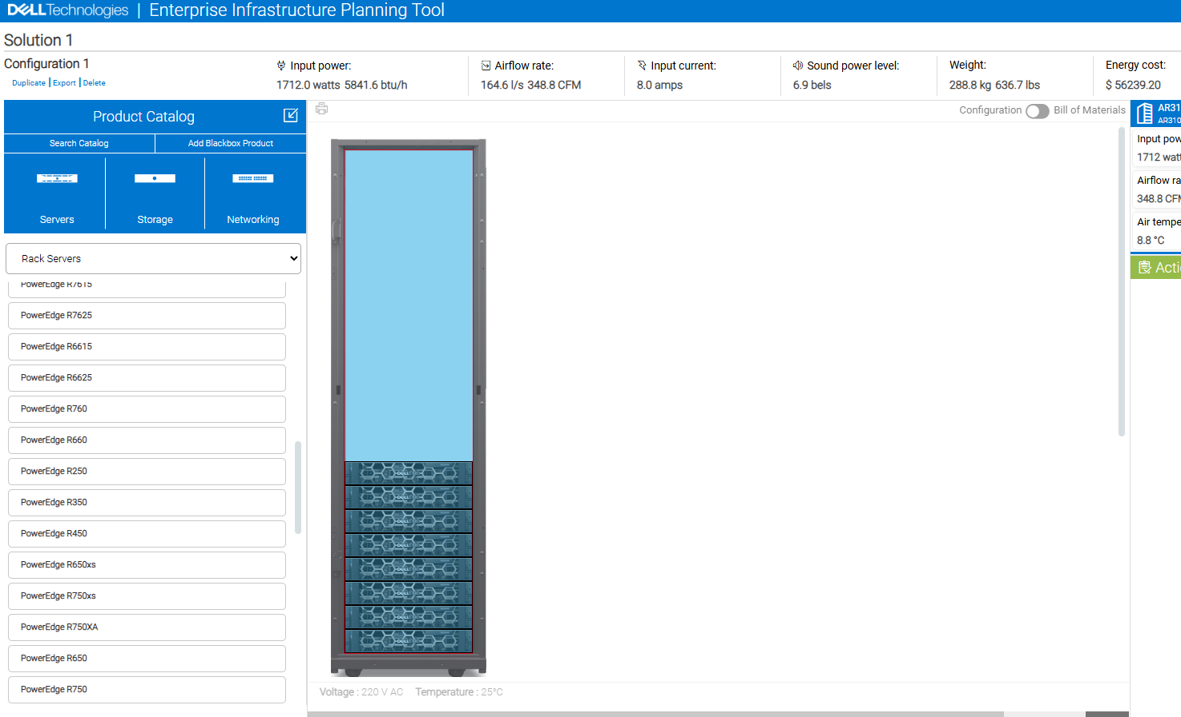
The specs for the second server farm, which requires twelve separate servers, sixteen CPU cores per server (192 across the farm), 256 GB RAM, one TB SSD, and Windows Operating Systems are as follows:
- Rack Server: Dell PowerEdge R770 (12)
- Intel® Xeon® 6 Performance 6714P 4.0G, 8C/16T, 24GT/s, 48M Cache, Turbo, (165W) DDR5-6400, Quantity 2 per server
- RAM: 32GB RDIMM, 6400MT/s, Dual Rank, Quantity 8 per server
- SSD: 1.92TB SSD SATA Mixed Use 6Gbps 512e 2.5in Hot-plug AG Drive, 3 DWPD, Quantity 1 per server
- OS: Windows Server 2025
Figure 2
Screenshot of Dell Calculator for Server Farm 2 using the above servers
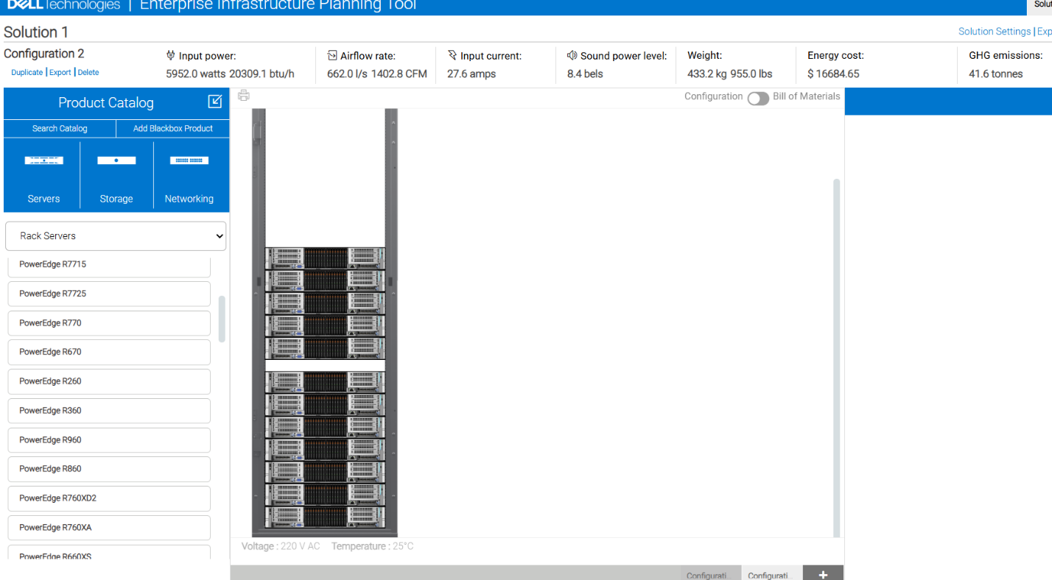

In contrast, the cost of Server Farms 1 and 2 in the clouds is as follows:
Figure 3
Screenshot of AWS calculator for Server Farm 1 with required specs
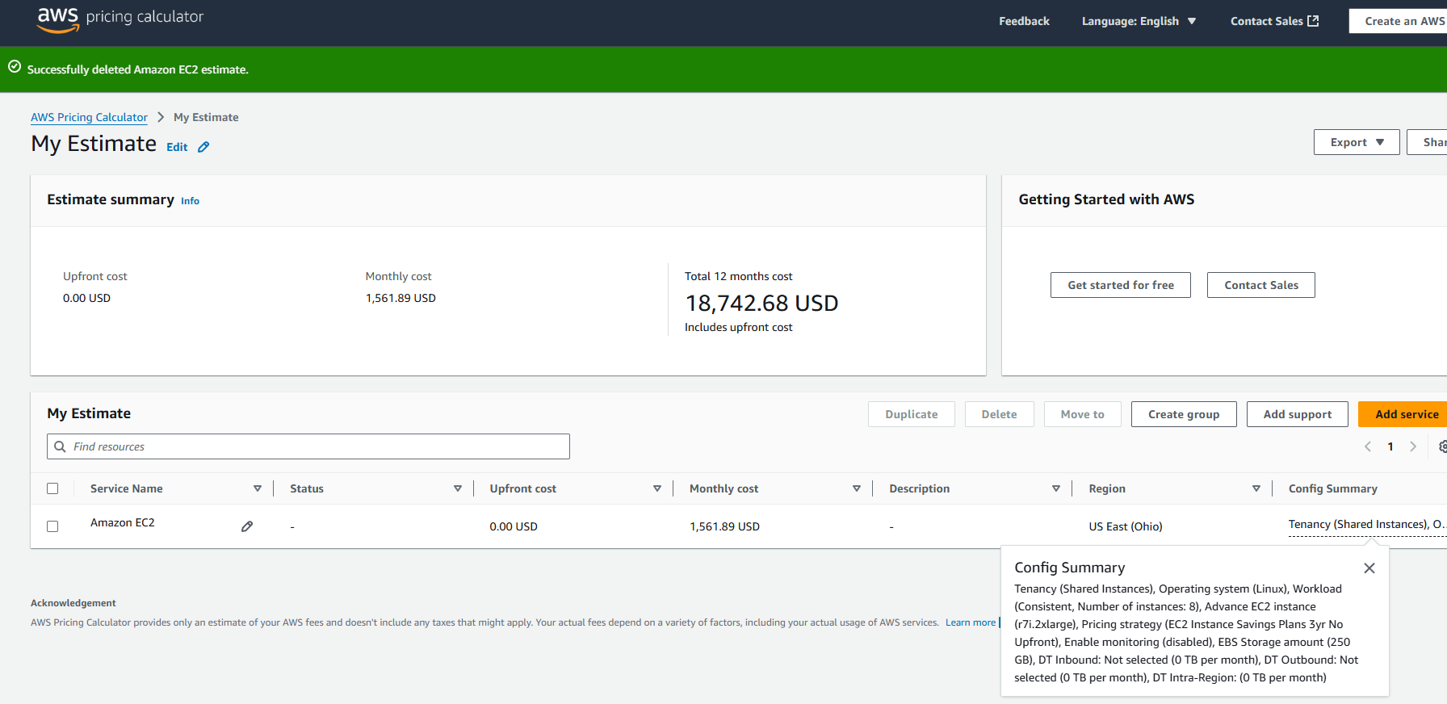
Figure 4
Screenshot of AWS calculator for Server Farm 2 with required specs
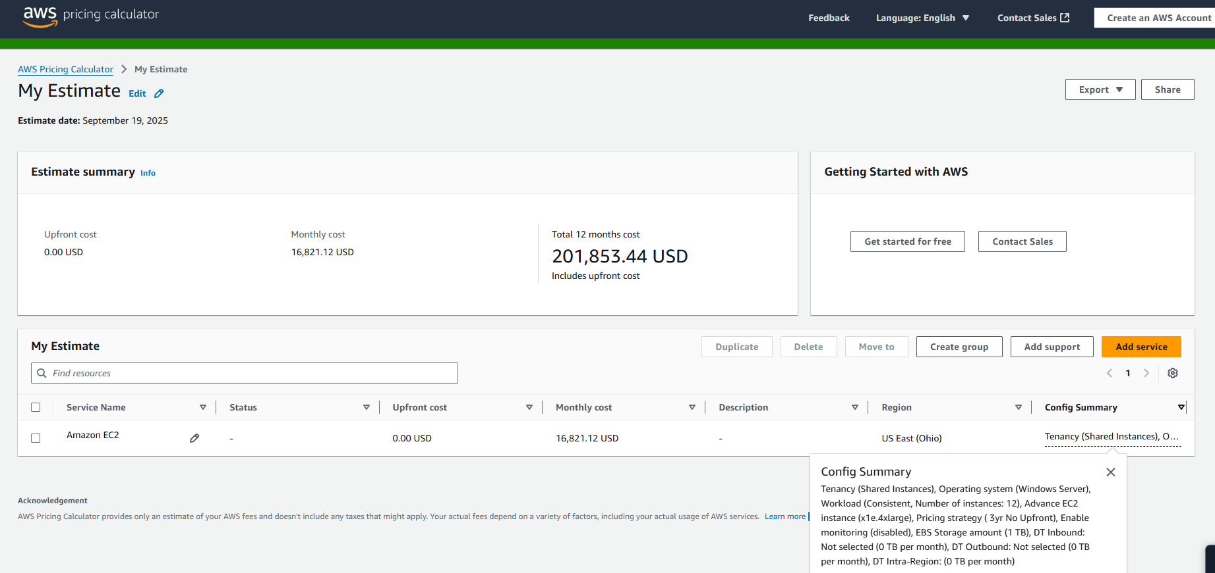
To properly understand the differences in cost between the two servers in different environments, total cost of ownership can be calculated. The following table represents these TCO calculations for a five-year lifecycle.
Server Farm 1- Cloud | Server Farm 1- Trad | Server Farm 2- Cloud | Server Farm 2- Trad
$93,713.40 | $298,843.12 | $1,009,267.20 | $620,247.57

The TCO table, while mostly accurate, does not consider additional security measures and operational costs inside of an on-premises traditional server farm environment. These factors, while important, are hard to assess as they are complex, multifaceted, and challenging to quantify. A corporation must determine how much security, what kinds of security measures, and exact salaries for professionals that manage the environment. What one company determines as satisfactory may not be satisfactory to another. These factors will absolutely inflate the TCO for the traditional server farms more. In Phoenix, the average yearly salary for an IT systems administrator is $77,434 (Zip Recruiter, 2025). Depending on the number of employees the company determines is adequate, this could add an additional cost of $1,935,850 in just salaries alone for the on-prem environments over a five-year period (for a team of five employees as an example).
I was able to factor in training for the on-prem environments, as Dell provides optional training when purchasing servers. For Server Farm 1, I purchased 10,000 training credits per server, which can be distributed across the team and redeemed at Learning.Dell.com up to one year after the order date. For Server Farm 2, I purchased nine one-year subscriptions to Dell Learning Hub per server. Warranties and services are two more examples of indirect costs that are associated with on-premises server farms. It is important to have these as with physical hardware, things can degrade and corrupt over time. For both on-prem server farms, I purchased a three-year warranty and five-year extended Dell ProSupport service for each server.
Examining the differences between the cloud and on-prem versions of the required infrastructure, cloud is the better option of the two in terms of price and scalability. The same amount of compute power can be achieved in the cloud infrastructure for $205,129.72 less in Server Farm 1, without factoring in the pay of employees. It is also important to note that for a cloud environment operational costs like salary will be significantly less as no employees are required to manage a physical infrastructure, just manage the cloud, which can be done by one or two workers. On the surface, the on-prem infrastructure for Server Farm 2 may appear less, but again, it does not factor in employee pay. Enterprise-grade hardware is extremely expensive and must be purchased up-front and must be maintained, whereas cloud infrastructure does not require an up-front payment. As far as scalability is concerned, cloud infrastructure resources and compute power can be added with a simple click of a button. With on-prem, the process is much more complex and requires a lengthy approval process, which includes determining what hardware is compatible and what budget the corporation aims to maintain. There may be additional training costs, especially if the hardware chosen is different than the current hardware in the server farm. On-prem environments also require a significant amount of energy consumption compared to cloud. This can be seen in the comparison table of the two traditional server farms, with the first five-year energy cost being $56,239.20 and the second $83,423.25. This cost is paid directly to the electricity provider, who determines the exact rate for kilowatt-hours. The infrastructure requirements did not account for redundancy, which would increase these costs even more. With cloud, this cost is bundled into the plan.
Even with the extreme costs associated with traditional infrastructure, some companies may prefer to go this route over a cloud infrastructure. For example, some industries, like healthcare, have strict data compliance regulations. Companies within this sector may be required to store sensitive data on premises. On-prem also gives companies full control over security policies, network segmentation, and physical access, which, in a cloud environment, is up to the third-party service provider.

References
Dell Technologies. (2025). On-Premise vs. Cloud | Dell USA. Dell. https://www.dell.com/en-us/lp/dt/on-premise-vs-cloud
Kale, V. (2015). Guide to cloud computing for business and technology managers: From distributed computing to cloudware applications (1st ed.). CRC Press.
Zip Recruiter. (2025). It Systems Administrator. Zip Recruiter. https://www.ziprecruiter.com/Salaries/It-Systems-Administrator-Salary-in-Phoenix,AZ

